|  |
| --- |
| By Cliff Rodriguez |
| Problem Set 3 |
| Econ 4811  Date: due Feb 28, 2018 |

|  |
| --- |
| Rodriguez, Cliff |

Contents

Question 1 2

Question 2 4

Question 3 4

Question 4 5

Question 5 7

**No table of figures entries found.**

# Question 1

1. 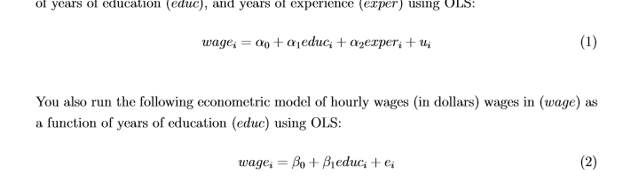

$\hat{α_{1}}$ = .65

Interpretation: For an additional year of education wage is expected to increase by $650, with experience held constant.

$\hat{α_{2}}$ = .07

Interpretation: for each additional year of experience wage is expected to increase by $70, with education held constant.

$\hat{β_{1}}$ = .55

Interpretation:

For each additional year of education hourly wage is expected to increase by 55 cents.

1. All else held constant, an individual with an additional three years of experience (Anna) will have a difference in wage of $210. The difference in wage is expected because $\hat{α_{2}}$ = .07. This is my best guess because the alpha value being evaluated is estimated and from a sample.
2. All else held constant a person who has five more years of education(Bob) is expected to have a wage difference of $3,250. The difference in wage is expected because $\hat{α_{1}}$ = .65. This is my best guess because the alpha value being evaluated is estimated and from a sample.
3. Say something about The correlation between educa and exper ….
4. Graph estimated relationship between education and wages for the entire sample
$${wage}_{i}= -.91+ .54\hat{{educ}_{i}}$$

5. Graph education and wages for people that have 10 years of experience.

$${wage}_{i}= α_{0}+ α_{1}{educ}_{i}+α_{2}{exper}_{i}+u_{i}$$

$$\hat{{wage}_{i}}= -3.39+ \hat{.64{educ}_{i}}+\hat{.07{exper}_{i}}$$

­

1. If $\hat{α_{1}}$ is different than $α_{1}$, $\hat{α_{1}}$ is not necessarily biased. There is a possibility of omitted variable bias, but it is also possible the sample taken did not yield a value for $\hat{α_{1}}$ was close to or equal to the true value of $α_{1}$*.*
2. BLUE analysis

For the values to be the same there are two possible cases:

* The partial effect of x2 on yhat is zero in the sample (bs hat = 0)
* X1 and x2 are uncorrelated and

# Question 2

$\overline{X} is distributed asymptotically normal with mean μ_{x} and variance 400.$

(iiii)

(iv)

(v)

# Question 3

$τ= \frac{200-160}{25}=1.6$

Degrees of freedom: 30 – 3 = 27

Display invttail(27,00.25) = 2.05

This is a two-tailed test

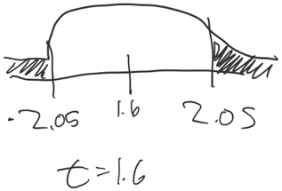

$τ= \frac{1.289 - 0}{.543}=2.37$

Degrees of freedom: 33 – 4 = 29

Display invttail(29, .005) = 2.76

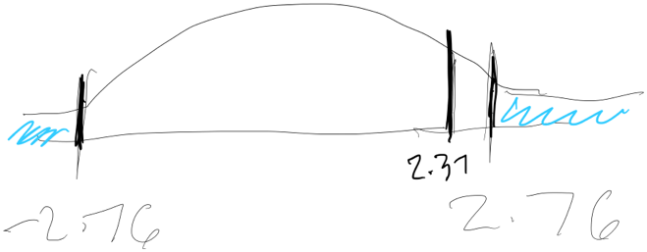

2.37 ∉ of the critical region and we cannot reject the null.

$τ= \frac{.355 - 0}{.073}=4.86$

Degrees of freedom: 33 - 4 = 29

Display invttail(29,0.025) = 2.05

One-sided test

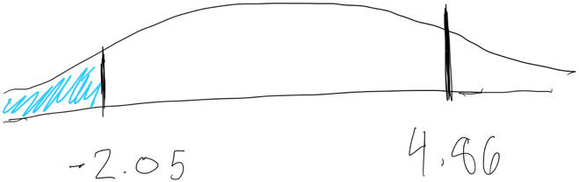

4.86 ∉ of the critical region and we cannot reject the null.

# Question 4

Unless otherwise noted, a normal distribution will be used because sample size is greater than 100 (n=1,198).



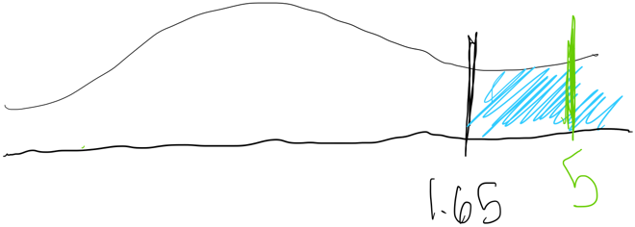

5 ∈ of the critical region; we reject the null.



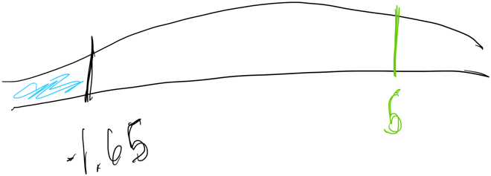

5 ∉ of the critical region; we cannot reject the null.

**Because the hypothesis can be interpreted both ways I did it both ways.**

1. A one unit increase in height has a 2.3% increase effect on wage.
2. Both age and education are important to include in the model. According to the model age has a roughly one percent effect on wages and education has a roughly 6 percent effect on wage.





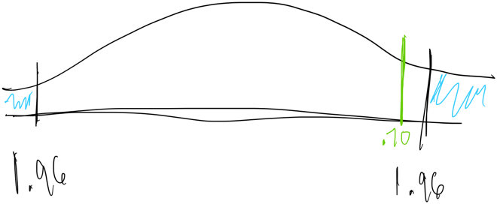

.70 ∉ of the critical region and we cannot reject the null.

1. 



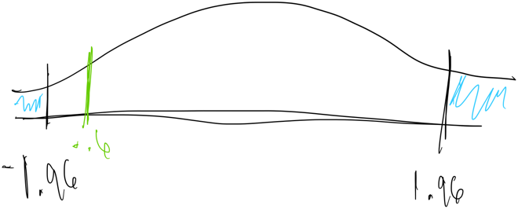

- 0.60 ∉ of the critical region; we cannot reject the null.

. display ttail(1191,-.6)

.72568981

$H_{0} :γ_{3}=0$

$H_{A} :γ_{3} ≠0$

$$τ= \frac{.084-0}{.201}= .42$$

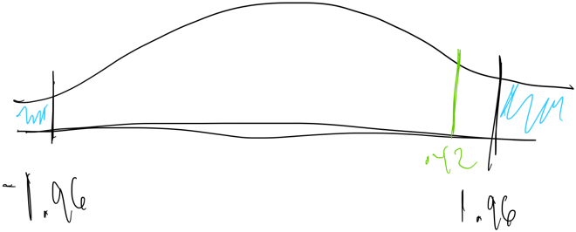

0.42 ∉ of the critical region; we cannot reject the null.

. display ttail(1191,.42)

.3372806

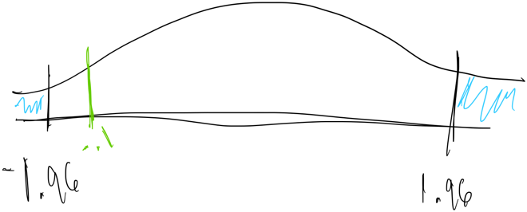

- 0.10 ∉ of the critical region; we cannot reject the null.

. display ttail(1191,-.1)

.53981942

# Question 5

|  |  |  |  |  |  |  |  |  |  |  |  |
| --- | --- | --- | --- | --- | --- | --- | --- | --- | --- | --- | --- |
| **All** | **N - original** | sqrt(n) | | Xbar | | s (std dev) | | s/sqrt(n) - original | | s/sqrt(n) - n = 15 | |
| Public | 20992 | 144.8861 | | 8.335 | | 5.581 | | 0.038519 | | 0.372066 | |
| Private | 2485 | 49.84977 | | 10.277 | | 4.996 | | 0.100221 | | 0.333066 | |
| **Academic Track** | |  |  | |  | |  | |  | |
| Public | 7115 | 84.35045 | | 11.571 | | 4.925 | | 0.058387 | | 0.328333 | |
| Private | 1668 | 40.84115 | | 11.538 | | 4.538 | | 0.111113 | | 0.302533 | |

|  |  |
| --- | --- |
|  | n = original |
| var – all | 0.107368778 |  |  |  |
| var - academic | 0.125520008 |  |  |  |
|  |  |

|  |  |
| --- | --- |
|  |  |
| All | 1.942 |
| Academic Track | -0.033 |

$${\hat{σ}}_{Priva{te}_{all}-P{ublic}_{all}} = \sqrt{{.0385}^{2}+{.10}^{2}}= 0.107$$

$${\hat{σ}}_{Priva{te}_{academic track}-P{ublic}_{academic track}}= \sqrt{{.058}^{2}+{.111}^{2}}= 0.126$$

$$H_{0} : μ_{all}^{private}-μ_{all}^{public}≤0$$

$$H_{A}: μ_{all}^{private}-μ_{all}^{public}>0$$

$τ= \frac{1.942-0}{.107}$ = 18.13

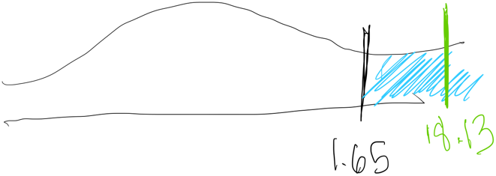

18.13 ∈ of the critical region and we reject the null

$$H_{0} : μ_{academic}^{private}-μ_{academic}^{public}≤0$$

$$H_{A}: μ_{academic}^{private}-μ_{academic}^{public}>0$$

$τ= \frac{- 0.033-0}{.126}$ = -.261

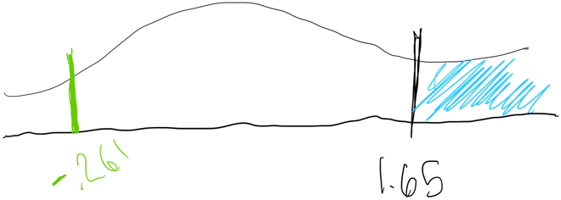

-.261 ∉ - we cannot reject the null

1. If the null changed to

$$H_{0} : μ_{all}^{private}-μ_{all}^{public}= 0$$

The test would indicate if the two were equal in value, and not give an indication if one is expected to outperform the other, which is the case if the null includes an inequality.

1. N = 15

|  |  |  |  |  |
| --- | --- | --- | --- | --- |
| **All** | n = 15 | Xbar | s (std dev) | s/sqrt(n) - n = 15 |
| Public | 15 | 8.335 | 5.581 | 0.372066 |
| Private | 15 | 10.277 | 4.996 | 0.333066 |

|  |  |
| --- | --- |
|  |  |
| All | 1.942 |

|  |  |
| --- | --- |
|  | n = 15 |
| $${\hat{σ}}_{Priva{te}_{all}-P{ublic}_{all}}$$ | 0.497 |

$$H_{0} : μ_{all}^{private}-μ_{all}^{public}≤0$$

$$H_{A}: μ_{all}^{private}-μ_{all}^{public}>0$$

$τ= \frac{1.94-0}{..497}$ = 3.90

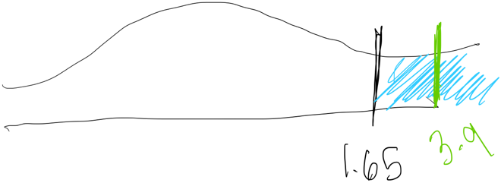

3.9 ∈ of the critical region and we reject the null

1. When entire populations are studied, private school students, on average, will outperform public school students on a standardized math test. The value of education in public and private school has different outcomes depending on if the student is in the academic track. If a student is in the academic track in a public school the mean is the highest in the populations studied.